

|  |
| --- |
| BatchMaster Software  Product Management  Functional Specification Document  <Acumatica> |

**DOCUMENT VERSION <1.0>**

**<November 25, 2019>**

**AUTHORS**

|  |  |  |
| --- | --- | --- |
| Name | Role | Department |
| Anmol Pandit | Solution Advisor | QA, Training, Compliance |
| Shachi Rairikar | Product Manager | Product Management Group |
|  |  |  |

**DOCUMENT HISTORY**

|  |  |  |  |
| --- | --- | --- | --- |
| Date | Version | Document Revision Description | Document Author |
| 25.11.2019 | 1.0 |  | Shachi Rairikar |
|  |  |  |  |
|  |  |  |  |
|  |  |  |  |
|  |  |  |  |

**APPROVALS**

|  |  |  |  |
| --- | --- | --- | --- |
| Approval Date | Approved Version | Approver Role | Approver |
|  |  |  |  |
|  |  |  |  |
|  |  |  |  |
|  |  |  |  |

Contents

1 Introduction 6

2 Terms and Definitions 6

3 Risks and Assumptions 6

4 Process Flow\Data Flow diagram 8

5 Functional Specifications 10

5.1 System Units 10

5.1.1 Description 10

5.1.2 Use case 10

5.1.3 Mock-up 10

5.1.4 Field level specification 10

Form Elements 10

Business Rules and Dependencies 10

Buttons, Special Functions (Actions) and Drill Downs 11

5.2 Formula Class 11

5.2.1 Description 11

5.2.2 Use case 11

5.2.3 Mock-up 11

5.2.4 Field level specification 12

Form Elements 12

Business Rules and Dependencies 12

Buttons, Special Functions (Actions) and Drill Downs 12

5.3 Formula Policy 13

5.3.1 Description 13

5.3.2 Use case 13

5.3.3 Mock-up 13

5.3.4 Field level specification 13

Form Elements 13

Business Rules and Dependencies 13

Buttons, Special Functions (Actions) and Drill Downs 14

5.4 Manufacturing Instructions 14

5.4.1 Description 14

5.4.2 Use case 14

5.4.3 Mock-up 14

5.4.4 Field level specification 15

Form Elements 15

Business Rules and Dependencies 15

Buttons, Special Functions (Actions) and Drill Downs 15

5.5 Physical Property Group Master 16

5.5.1 Description 16

5.5.2 Use case 16

5.5.3 Mock-up 16

5.5.4 Field level specification 16

Form Elements 16

Business Rules and Dependencies 17

Buttons, Special Functions (Actions) and Drill Downs 17

5.6 Physical Property Master 17

5.6.1 Description 17

5.6.2 Use case 18

5.6.3 Mock-up 18

5.6.4 Field level specification 18

Form Elements 18

Business Rules and Dependencies 18

Buttons, Special Functions (Actions) and Drill Downs 19

5.7 Item Physical Property Master 19

5.7.1 Description 19

5.7.2 Use case 20

5.7.3 Mock-up 20

5.7.4 Field level specification 20

Form Elements 20

Business Rules and Dependencies 21

Buttons, Special Functions (Actions) and Drill Downs 21

5.8 Physical Property Equation 22

5.8.1 Description 22

5.8.2 Use case 22

5.8.3 Mock-up 22

5.8.4 Field level specification 22

Form Elements 22

Business Rules and Dependencies 22

Buttons, Special Functions (Actions) and Drill Downs 23

5.9 Formulation – Header & Toolbar 23

5.9.1 Description 23

5.9.2 Use case 24

5.9.3 Mock-up 24

5.9.4 Field level specification 24

Form Elements 24

Business Rules and Dependencies 25

Buttons, Special Functions (Actions) and Drill Downs 26

5.10 Formulation – Tab 1 (Details) 27

5.10.1 Description 27

5.10.2 Use case 27

5.10.3 Mock-up 27

5.10.4 Field level specification 28

Form Elements 28

Business Rules and Dependencies 28

Buttons, Special Functions (Actions) and Drill Downs 29

5.11 Formulation – Tab 2 (Operations) 29

5.12 Formulation – Tab 3 (Consumables) 29

5.13 Formulation – Tab 4 (Items) 29

5.14 Formulation – Tab 5 (QC) 29

5.15 Formulation – Tab 6 (Costing) 29

5.16 Bill of Material 29

5.16.1 Description 29

5.16.2 Use case 29

5.16.3 Mock-up 29

5.16.4 Field level specification 29

Form Elements 29

Business Rules and Dependencies 30

Buttons, Special Functions (Actions) and Drill Downs 30

# Introduction

Acumatica ERP system is a cloud based system catering to small and midmarket organizations in the discrete manufacturing industries. Acumatica does not have the capability to handle process manufacturing. Therefore there is the need to develop process manufacturing add-on for Acumatica.

BatchMaster which has been the leader in the ERP software for process manufacturing industry in the mid and small market segment has been approached to develop a process manufacturing add-on for Acumatica.

# Terms and Definitions

|  |  |  |
| --- | --- | --- |
| Term/Acronym | Definition | Description |
|  |  |  |

# Risks and Assumptions

1. Approval System

The approval system provided by Acumatica as standard offering will be used for Formula approvals. Any changes made by Acumatica in their approval system in their future versions will affect the process manufacturing add-on and its compatibility will need to be tested and verified.

1. Costing / Valuation Methods

The costing and valuation system provided by Acumatica as standard offering will be used for costing analysis of Formulation and Bill of Material. Any changes made by Acumatica in their costing or valuation methods in their future versions will affect the process manufacturing add-on and its compatibility will need to be tested and verified.

1. Version Control

There will be version number on formulas and BOM to track and save different versions of formulas and BOMs.

The revision number provided by Acumatica as standard offering will be used to identify and maintain different routes of the same formula and BOM.

1. Accounting

Since manufacturing will be completely handled by Acumatica just like standard production in Acumatica; there will be no impact of the process manufacturing add-on on the accounting side.

1. QC

QC add-on created for Acumatica will be used in process manufacturing.

1. By-product

Since Acumatica manufacturing does not have a separate field or tab for by-products lines with negative quantities will be used to record by-products in formulation.

1. Consumables

The consumables in formulation will be recorded as tools defined in Acumatica as the latter uses the terminology “tools” for consumables.

1. Labor

Different routes are defined in Acumatica as different versions of the same formula. Labor will be completely handled through routing which will work just like it does in the standard offering of Acumatica. Any changes made by Acumatica in their routing system in their future versions will affect the process manufacturing add-on and its compatibility will need to be tested and verified.

# Process Flow\Data Flow diagram

There will be two main screens in the process manufacturing add-on: one for Formulation and the other for Bill of Materials. The data from these two screens will be copied to the Bill of Materials screen table of Acumatica and from there it would flow to Acumatica manufacturing as per the standard Acumatica functionality. The standard Bill of Materials screen of Acumatica will not be visible to the users.

Different routes of the same formula will be saved as different manually entered revision numbers of the same formula. The version number (which will be different from revision number) will be auto-generated and used to track the different versions of the formula. The BOM screen will be a replica of the BOM screen of Acumatica with the additional field to associate formula with its revision number, specify revision type (intermediate /mix /fill /assembly) and fill level with fill unit.

Here is the brief summary of the screens for the process manufacturing add-on.

1. System Units

This screen will be introduced to define the system weight and volume since these are not available in Acumatica. Acumatica being a discrete manufacturing software does not support the concept of system weight and system volume.

1. Formula Class

This screen will be introduced to define classification for formulas. This may be used for any type of categorization or classification of formulas.

1. Formula Policy

This screen will be introduced to enter policies that will govern user access rights to the different tabs of formulation screen.

1. Manufacturing Instructions

This screen will be introduced to define repetitive texts that need to be added to different formulas.

1. Physical Property Group Master

This screen will be introduced to define groups of physical properties.

1. Physical Property Master

This screen will be introduced to define the physical properties to be used in formulation.

1. Item Physical Property Master

This screen will be introduced to associate the items created in Acumatica with the physical properties defined on the Physical Property Master screen in the process manufacturing add-on.

1. Physical Property Equation

This screen will be introduced to maintain physical property equations used in laboratory to create formulas.

1. Formulation

This screen will be introduced to create formulas based on physical property analysis; maintain and view formulas with different routings and also perform their costing analysis.

1. Bill of Material

Bill of Material screen will be the exact replica of the standard Acumatica Bill of Material screen with the addition of formula and fill level.

# Functional Specifications

## Common Validations

1. Primary Key on any screen will always be in capital letters irrespective of whether user enters it with or without keeping the CAPS LOCK on.
2. On any screen if a user navigates to another record or hits the cancel button without saving then a message will be displayed “Any unsaved changes will be discarded. Do you want to continue? “Yes” or “No”” If the user clicks on “Yes” all the unsaved changes would be lost.
3. If for some reason the connection to the database is lost while executing a process or printing a report or saving a record valid error message should be displayed.

## System Units

### Description

On this screen user will define the system units of measure for weight and volume. The system unit can be thought of as the universal unit for weight or volume. The choices for each will be defined by your choice of measurement system (US or Metric). This will be a one-time setup that cannot be modified once a formula has been created.

It will be mandatory to define the conversion for items used in formulas from their respective units of measures to system weight and system volume. The total formula weight and volume will be displayed in terms of system weight and volume.

### Use case

A company may choose system weight and system volume according to the nature of its business and its requirements. The example can be kilogram as system weight and litre as system volume or pounds as system weight and gallon as system volume.

### Mock-up

|  |  |
| --- | --- |
| **System Units** |  |
|  |  |
| **System Weight** |  |
| **System Volume** |  |
|  |  |

### Field level specification

### Form Elements

|  |  |  |  |  |  |  |  |
| --- | --- | --- | --- | --- | --- | --- | --- |
| Field Caption | Control Type | Mandatory | Editable | Data Type & Length | Default Value | Data Example | Data Entry Source |
| *<Label name>* | *<specify the control type on screen>* | *<specify if field is mandatory>* | *<specify if field is editable>* | *<Specify the data type of the field>* | *<Specify default value>* | *<Provide an example of the data>* | *<Specify the source of the data>* |
| System Weight | Lookup | Yes | Yes | Alpha-numeric; Field length as in Acumatica UOM | NA | Kg | Acumatica Unit of Measure |
| System Volume | Lookup | Yes | Yes | Alpha-numeric; Field length as in Acumatica UOM | NA | Lt | Acumatica Unit of Measure |

### Business Rules and Dependencies

|  |  |  |  |  |
| --- | --- | --- | --- | --- |
| Field Caption | Validation / Business Rules | Error Messages | Data Dependencies | Additional Info/ Notes |
| *<Label name>* | *<Specify the validation\business rules & Calculations applicable to the form element>* | *<List the error message and possible conditions>* | *<Specify the data dependencies>* | *<Provide any additional information here>* |
| System Weight | System Weight shall be a valid unit of measure defined in Acumatica | For incorrect system weight display an error message: “Please provide a valid system weight” | Unit of Measure must be defined in Acumatica | Once even one Formula has been defined system weight cannot be changed. |
| System Volume | System Volume shall be a valid unit of measure defined in Acumatica.  System Volume cannot be same as System Weight. | For incorrect system volume display an error message: “Please provide a valid system volume”  If System Volume is same as System Weight display an error message: “System Volume is same as System Weight. Please select another UOM”. | Unit of Measure must be defined in Acumatica | Once even one Formula has been defined system volume cannot be changed. |

### Buttons, Special Functions (Actions) and Drill Downs

|  |  |  |  |  |  |  |
| --- | --- | --- | --- | --- | --- | --- |
| Buttons, Lookups, Drill-Downs | Events (On-Click, Mouse Over etc.) | Validation | Visible, Enabled\Disabled | Lookup Source and Data transfer rule | Navigate To | Error Messages |
| *<Label name>* | *<Specify the operation that would be performed on an event e.g. On-Click, Mouse Over etc.>* | *<Specify the validation rules applicable on button events.>* | *<Specify the default visibility and state>* | *<Specify the source of the lookup and name of the transferred and source fields.>* | *<Specify the target action or screen for the button or drill-down>* | *<List the error message and possible conditions>* |
| Save & Close | **On-Click: -** Will exit screen after saving data. | Verify that valid UOMs have been selected.  Verify that System Volume is not same as System Weight | It should be visible and enabled in edit mode. | NA | NA | “Please provide a valid system weight”  “Please provide a valid system volume”  “System Volume is same as System Weight. Please select another UOM”. |
| Cancel | **On-Click: -** Will exit screen without saving data. | None | It should be visible and enabled always. | NA | NA | NA |
| Save | **On-Click: -** Will save data. | Verify that valid UOMs have been selected.  Verify that System Volume is not same as System Weight. | It should be visible and enabled in edit mode. | NA | NA | “Please provide a valid system weight”  “Please provide a valid system volume”  “System Volume is same as System Weight. Please select another UOM”. |

## Formula Class

### Description

Formula classes will be used to group formulas by any dimension of users’ choice.

### Use case

In the paint industry one might define distempers, emulsions, and oil paints as classes. In the bakery industry, classes might be defined as white bread, wheat bread, and dinner rolls.

### Mock-up

|  |  |
| --- | --- |
| **Formula Class** |  |
|  |  |
| **Formula Class ID** |  |
| **Formula Class Description** |  |
|  |  |

### Field level specification

### Form Elements

|  |  |  |  |  |  |  |  |
| --- | --- | --- | --- | --- | --- | --- | --- |
| Field Caption | Control Type | Mandatory | Editable | Data Type & Length | Default Value | Data Example | Data Entry Source |
| *<Label name>* | *<specify the control type on screen>* | *<specify if field is mandatory>* | *<specify if field is editable>* | *<Specify the data type of the field>* | *<Specify default value>* | *<Provide an example of the data>* | *<Specify the source of the data>* |
| Formula Class ID | Textbox | Yes | No | Alpha-numeric; 10 | NA | CAP | User entry |
| Formula Class Description | Textbox | No | Yes | Alpha-numeric; 100 | NA | Capsules | User Entry |

### Business Rules and Dependencies

|  |  |  |  |  |
| --- | --- | --- | --- | --- |
| Field Caption | Validation / Business Rules | Error Messages | Data Dependencies | Additional Info/ Notes |
| *<Label name>* | *<Specify the validation\business rules & Calculations applicable to the form element>* | *<List the error message and possible conditions>* | *<Specify the data dependencies>* | *<Provide any additional information here>* |
| Formula Class ID | * This field will be editable in the insert mode. After saving it will be disabled. * Formula Class ID should be unique. * This field cannot be blank. | For repetitive formula class id an error message will be displayed: “This Formula Class ID already exists.”  For blank formula class id an error message will be displayed: “Formula Class ID cannot be blank” | None | None |
| Formula Class Description | None | None | None | None |

### Buttons, Special Functions (Actions) and Drill Downs

|  |  |  |  |  |  |  |
| --- | --- | --- | --- | --- | --- | --- |
| Buttons, Lookups, Drill-Downs | Events (On-Click, Mouse Over etc.) | Validation | Visible, Enabled\Disabled | Lookup Source and Data transfer rule | Navigate To | Error Messages |
| *<Label name>* | *<Specify the operation that would be performed on an event e.g. On-Click, Mouse Over etc.>* | *<Specify the validation rules applicable on button events.>* | *<Specify the default visibility and state>* | *<Specify the source of the lookup and name of the transferred and source fields.>* | *<Specify the target action or screen for the button or drill-down>* | *<List the error message and possible conditions>* |
| Save & Close | **On-Click: -** Will exit screen after saving data. | Verify that the Formula Class ID is unique and not blank. | It should be visible and enabled in edit mode. | NA | NA | “This formula class id already exists.”  “Formula Class ID cannot be blank” |
| Cancel | **On-Click: -** Will exit screen without saving data. | None | It should be visible and enabled always. | NA | NA | NA |
| Save | **On-Click: -** Will save data. | Verify that the Formula Class ID is unique and not blank. | It should be visible and enabled in edit mode. | NA | NA | “This formula class id already exists.”  “Formula Class ID cannot be blank” |
| Add New Record | **On-Click: -** Will re-open screen in insert mode | None | It should be visible and enabled always. | NA | NA | NA |
| Delete | **On-Click: -** Will delete record | Verify that reference does not exist. | It should be visible and enabled always. | NA | NA | “Cannot delete record. Reference exists.” |
| Navigate to First Record | **On-Click: -** Will navigate to first record | None | It should be visible and enabled always. | NA | First record of Formula Class screen | NA |
| Navigate to Previous Record | **On-Click: -** Will navigate to previous record | None | It should be visible and enabled always. | NA | Previous record of Formula Class screen | NA |
| Navigate to Next Record | **On-Click: -** Will navigate to next record | None | It should be visible and enabled always. | NA | Next record of Formula Class screen | NA |
| Navigate to Last Record | **On-Click: -** Will navigate to last record | None | It should be visible and enabled always. | NA | Last record of Formula Class screen | NA |

## Formula Policy

### Description

This will determine or govern the user access rights to the different tabs of formulation screen.

### Use case

### Mock-up

|  |  |
| --- | --- |
| **Formula Policy** |  |
|  |  |
| **Formula Policy ID** |  |
| **Description** |  |
|  |  |

### Field level specification

### Form Elements

|  |  |  |  |  |  |  |  |
| --- | --- | --- | --- | --- | --- | --- | --- |
| Field Caption | Control Type | Mandatory | Editable | Data Type & Length | Default Value | Data Example | Data Entry Source |
| *<Label name>* | *<specify the control type on screen>* | *<specify if field is mandatory>* | *<specify if field is editable>* | *<Specify the data type of the field>* | *<Specify default value>* | *<Provide an example of the data>* | *<Specify the source of the data>* |
| Formula Policy ID | Textbox | Yes | No | Alpha-numeric; 2 | NA | A | User entry |
| Description | Textbox | No | Yes | Alpha-numeric; 100 | NA | Active | User Entry |

### Business Rules and Dependencies

|  |  |  |  |  |
| --- | --- | --- | --- | --- |
| Field Caption | Validation / Business Rules | Error Messages | Data Dependencies | Additional Info/ Notes |
| *<Label name>* | *<Specify the validation\business rules & Calculations applicable to the form element>* | *<List the error message and possible conditions>* | *<Specify the data dependencies>* | *<Provide any additional information here>* |
| Formula Policy ID | * This field will be editable in the insert mode. After saving it will be disabled. * Formula Policy ID should be unique * Formula Policy ID cannot be blank | For repetitive formula policy id display an error message: “This Formula Policy ID already exists.”  For blank Formula Policy ID display an error message “Formula Policy ID cannot be blank.” | None | None |
| Description | None | None | None | None |

### Buttons, Special Functions (Actions) and Drill Downs

|  |  |  |  |  |  |  |
| --- | --- | --- | --- | --- | --- | --- |
| Buttons, Lookups, Drill-Downs | Events (On-Click, Mouse Over etc.) | Validation | Visible, Enabled\Disabled | Lookup Source and Data transfer rule | Navigate To | Error Messages |
| *<Label name>* | *<Specify the operation that would be performed on an event e.g. On-Click, Mouse Over etc.>* | *<Specify the validation rules applicable on button events.>* | *<Specify the default visibility and state>* | *<Specify the source of the lookup and name of the transferred and source fields.>* | *<Specify the target action or screen for the button or drill-down>* | *<List the error message and possible conditions>* |
| Save & Close | **On-Click: -** Will exit screen after saving data. | Verify that the Formula Policy ID is unique and not blank. | It should be visible and enabled in the edit mode. | NA | NA | “This Formula Policy ID already exists.”  “Formula Policy ID cannot be blank.” |
| Cancel | **On-Click: -** Will exit screen without saving data. | None | It should be visible and enabled always. | NA | NA | NA |
| Save | **On-Click: -** Will save data. | Verify that the Formula Policy ID is unique and not blank. | It should be visible and enabled in the edit mode. | NA | NA | “This Formula Policy ID already exists.”  “Formula Policy ID cannot be blank.” |
| Add New Record | **On-Click: -** Will re-open screen in insert mode | None | It should be visible and enabled always. | NA | NA | NA |
| Delete | **On-Click: -** Will delete record | Verify that reference does not exist. | It should be visible and enabled always. | NA | NA | “Cannot delete record. Reference exists.” |
| Navigate to First Record | **On-Click: -** Will navigate to first record | None | It should be visible and enabled always. | NA | First record of Formula Policy screen | NA |
| Navigate to Previous Record | **On-Click: -** Will navigate to previous record | None | It should be visible and enabled always. | NA | Previous record of Formula Policy screen | NA |
| Navigate to Next Record | **On-Click: -** Will navigate to next record | None | It should be visible and enabled always. | NA | Next record of Formula Policy screen | NA |
| Navigate to Last Record | **On-Click: -** Will navigate to last record | None | It should be visible and enabled always. | NA | Last record of Formula Policy screen | NA |

## Manufacturing Instructions

### Description

Standard manufacturing instructions for use in formulas will be entered on this screen. They are stored in a table, which means once they are defined, these instructions can be inserted into formulas just by entering their ID.

If there are specific manufacturing instructions that will be used in more than one formula, then they should be entered on this screen. This will save time and reduce data entry errors while entering formulas.

### Use case

Some instructions are repetitive in nature, like, “mix the ingredients well”. For such repetitive texts boilerplates can be defined to save time and effort and reduce chances of making mistakes.

### Mock-up

|  |  |
| --- | --- |
| **Manufacturing Instructions** | |
|  |  |
| **Boilerplate ID** |  |
| **Text** |  |
|  |

### Field level specification

### Form Elements

|  |  |  |  |  |  |  |  |
| --- | --- | --- | --- | --- | --- | --- | --- |
| Field Caption | Control Type | Mandatory | Editable | Data Type & Length | Default Value | Data Example | Data Entry Source |
| *<Label name>* | *<specify the control type on screen>* | *<specify if field is mandatory>* | *<specify if field is editable>* | *<Specify the data type of the field>* | *<Specify default value>* | *<Provide an example of the data>* | *<Specify the source of the data>* |
| Boilerplate ID | Textbox | Yes | No | Alpha-numeric; 50 | NA | B01 | User entry |
| Text | Textbox | Yes | Yes | Alpha-numeric; 4000 | NA | Mix the ingredients well. | User entry |

### Business Rules and Dependencies

|  |  |  |  |  |
| --- | --- | --- | --- | --- |
| Field Caption | Validation / Business Rules | Error Messages | Data Dependencies | Additional Info/ Notes |
| *<Label name>* | *<Specify the validation\business rules & Calculations applicable to the form element>* | *<List the error message and possible conditions>* | *<Specify the data dependencies>* | *<Provide any additional information here>* |
| Boilerplate ID | * This field will be editable in the insert mode. After saving it will be disabled. * Boilerplate ID should be unique. * Boilerplate ID cannot be blank. | For repetitive Boilerplate ID display an error message: “This Boilerplate ID already exists.”  For blank Boilerplate ID display an error message: “Boilerplate ID cannot be blank.” | None | None |
| Text | None | None | None | None |

### Buttons, Special Functions (Actions) and Drill Downs

|  |  |  |  |  |  |  |
| --- | --- | --- | --- | --- | --- | --- |
| Buttons, Lookups, Drill-Downs | Events (On-Click, Mouse Over etc.) | Validation | Visible, Enabled\Disabled | Lookup Source and Data transfer rule | Navigate To | Error Messages |
| *<Label name>* | *<Specify the operation that would be performed on an event e.g. On-Click, Mouse Over etc.>* | *<Specify the validation rules applicable on button events.>* | *<Specify the default visibility and state>* | *<Specify the source of the lookup and name of the transferred and source fields.>* | *<Specify the target action or screen for the button or drill-down>* | *<List the error message and possible conditions>* |
| Save & Close | **On-Click: -** Will exit screen after saving data. | Verify that the Boilerplate ID is unique.  Verify that Boilerplate ID is not blank. | It should be visible and enabled in the edit mode. | NA | NA | “This Boilerplate ID already exists.”  “Boilerplate ID cannot be blank.” |
| Cancel | **On-Click: -** Will exit screen without saving data. | None | It should be visible and enabled always. | NA | NA | NA |
| Save | **On-Click: -** Will save data. | Verify that the Boilerplate ID is unique.  Verify that Boilerplate ID is not blank. | It should be visible and enabled in the edit mode. | NA | NA | “This Boilerplate ID already exists.”  “Boilerplate ID cannot be blank.” |
| Add New Record | **On-Click: -** Will re-open screen in insert mode | None | It should be visible and enabled always. | NA | NA | NA |
| Delete | **On-Click: -** Will delete record | Verify that reference does not exist. | It should be visible and enabled always. | NA | NA | “Cannot delete record. Reference exists.” |
| Navigate to First Record | **On-Click: -** Will navigate to first record | None | It should be visible and enabled always. | NA | First record of Manufacturing Instructions screen | NA |
| Navigate to Previous Record | **On-Click: -** Will navigate to previous record | None | It should be visible and enabled always. | NA | Previous record of Manufacturing Instructions screen | NA |
| Navigate to Next Record | **On-Click: -** Will navigate to next record | None | It should be visible and enabled always. | NA | Next record of Manufacturing Instructions screen | NA |
| Navigate to Last Record | **On-Click: -** Will navigate to last record | None | It should be visible and enabled always. | NA | Last record of Manufacturing Instructions screen | NA |

## Physical Property Group Master

### Description

The Physical Property Group Master screen will help users to establish user-defined sequence of the Physical Properties for display on the Formulation Screen. Users will define physical properties groups and define sequencing of the group. This will help users to view the required or important properties on the top and less important or un-used properties at the end.

### Use case

Examples of physical property groups can be microbiological, chemical, mechanical, etc.

### Mock-up

|  |  |  |  |
| --- | --- | --- | --- |
| **Physical Property Group Master** | | |  |
|  |  |  |  |
| **Seq. no.** | **Group Code** | **Description** | **Remarks** |
|  |  |  |  |
|  |  |  |  |
|  |  |  |  |
|  |  |  |  |
|  |  |  |  |
|  |  |  |  |

### Field level specification

### Form Elements

|  |  |  |  |  |  |  |  |
| --- | --- | --- | --- | --- | --- | --- | --- |
| Field Caption | Control Type | Mandatory | Editable | Data Type & Length | Default Value | Data Example | Data Entry Source |
| *<Label name>* | *<specify the control type on screen>* | *<specify if field is mandatory>* | *<specify if field is editable>* | *<Specify the data type of the field>* | *<Specify default value>* | *<Provide an example of the data>* | *<Specify the source of the data>* |
| Seq. no. | Textbox | Yes | No | Numeric; 10 | NA | T1 | Auto-generated and Auto-incremental |
| Group Code | Textbox | Yes | Yes | Alpha-numeric; 10 | None | Viscosity | User Entry |
| Description | Textbox | Yes | Yes | Alpha-numeric; 100 | None | Viscosity | User Entry |
| Remarks | Textbox | No | Yes | Alpha-numeric; 4000 | None | Viscosity | User Entry |

### Business Rules and Dependencies

|  |  |  |  |  |
| --- | --- | --- | --- | --- |
| Field Caption | Validation / Business Rules | Error Messages | Data Dependencies | Additional Info/ Notes |
| *<Label name>* | *<Specify the validation\business rules & Calculations applicable to the form element>* | *<List the error message and possible conditions>* | *<Specify the data dependencies>* | *<Provide any additional information here>* |
| Seq. no. | Auto generated and Auto incremental | None | None | None |
| Group Code | * This field will be editable in the insert mode. After saving it will be disabled. * Group Code should be unique. * Group Code cannot be blank. | For repetitive Group Code display an error message: “This Group Code already exists.”  For blank Group Code display an error message “Group Code cannot be blank.” | None | None |
| Description | None | None | None | None |
| Remarks | None | None | None | None |

### Buttons, Special Functions (Actions) and Drill Downs

|  |  |  |  |  |  |  |
| --- | --- | --- | --- | --- | --- | --- |
| Buttons, Lookups, Drill-Downs | Events (On-Click, Mouse Over etc.) | Validation | Visible, Enabled\Disabled | Lookup Source and Data transfer rule | Navigate To | Error Messages |
| *<Label name>* | *<Specify the operation that would be performed on an event e.g. On-Click, Mouse Over etc.>* | *<Specify the validation rules applicable on button events.>* | *<Specify the default visibility and state>* | *<Specify the source of the lookup and name of the transferred and source fields.>* | *<Specify the target action or screen for the button or drill-down>* | *<List the error message and possible conditions>* |
| Save & Close | **On-Click: -** Will exit screen after saving data. | Verify that Group Code is unique.  Verify that Group Code is not blank. | It should be visible and enabled in the edit mode. | NA | NA | “This group code already exists.”  “Group Code cannot be blank.” |
| Cancel | **On-Click: -** Will exit screen without saving data. | None | It should be visible and enabled always. | NA | NA | NA |
| Save | **On-Click: -** Will save data. | Verify that Group Code is unique. Verify that Group Code is not blank. | It should be visible and enabled in the edit mode. | NA | NA | “This group code already exists.”  “Group Code cannot be blank.” |

## Physical Property Master

### Description

A screen will be provided to enter the physical properties of items. These properties define the nature, appearance, or behaviour of the raw materials. The system will use the material physical properties of individual ingredients of a formula and simple equations to determine the overall nature, appearance, or behaviour of the formulas.

A maximum of 999 physical properties will be defined in this screen. Each property will be uniquely identified by the series (T1-T999) displayed adjacent to the description.

### Use case

Examples of physical properties are weight, volume, mass, colour, density, viscosity, boiling point, melting point, etc.

### Mock-up

|  |  |  |  |  |  |  |
| --- | --- | --- | --- | --- | --- | --- |
| **Physical Property Master** | | |  |  |  |  |
|  |  |  |  |  |  |  |
| **Seq. no.** | **Description** | **Type** | **Factor** | **Tag Name** | **Property Unit** | **Group** |
|  |  |  |  |  |  |  |
|  |  |  |  |  |  |  |
|  |  |  |  |  |  |  |
|  |  |  |  |  |  |  |
|  |  |  |  |  |  |  |

### Field level specification

### Form Elements

|  |  |  |  |  |  |  |  |
| --- | --- | --- | --- | --- | --- | --- | --- |
| Field Caption | Control Type | Mandatory | Editable | Data Type & Length | Default Value | Data Example | Data Entry Source |
| *<Label name>* | *<specify the control type on screen>* | *<specify if field is mandatory>* | *<specify if field is editable>* | *<Specify the data type of the field>* | *<Specify default value>* | *<Provide an example of the data>* | *<Specify the source of the data>* |
| Seq. no. | Textbox | Yes | No | Alpha-numeric; 10 | NA | T1 | Auto-generated and auto-incremental |
| Description | Textbox | Yes | Yes | Alpha-numeric; 100 | None | Viscosity | User Entry |
| Type | Dropdown | Yes | No | Alpha-numeric; 10 | None | Weight | Weight / Volume / Constant |
| Factor | Textbox | Yes | Yes | Numeric; 18 | 0 | 1 | User Entry |
| Tag Name | Textbox | Yes | Yes | Alpha-numeric; 254 | None |  | User Entry |
| Property Unit | Lookup | Yes | Yes | Alpha-numeric; 100 | None | Gm | Acumatica Unit of Measure |
| Group | Lookup | Yes | Yes | Alpha-numeric; 10 | None | Viscosity | Physical Property Group Master |

### Business Rules and Dependencies

|  |  |  |  |  |
| --- | --- | --- | --- | --- |
| Field Caption | Validation / Business Rules | Error Messages | Data Dependencies | Additional Info/ Notes |
| *<Label name>* | *<Specify the validation\business rules & Calculations applicable to the form element>* | *<List the error message and possible conditions>* | *<Specify the data dependencies>* | *<Provide any additional information here>* |
| Seq. no. | Auto-generated and auto-incremental | None | None | None |
| Description | None | None | None | None |
| Type | None | None | None | None |
| Factor | None | None | None | None |
| Tag Name | None | None | None | None |
| Property Unit | Should be valid Acumatica Unit of Measure | For incorrect unit display an error message: “Please provide a valid property unit” | Unit of measure must be defined in Acumatica. | None |
| Group | Should be valid Physical Property Group | For incorrect group display an error message: “Please provide a valid physical property group” | Physical Property Group must be defined. | None |

### Buttons, Special Functions (Actions) and Drill Downs

|  |  |  |  |  |  |  |
| --- | --- | --- | --- | --- | --- | --- |
| Buttons, Lookups, Drill-Downs | Events (On-Click, Mouse Over etc.) | Validation | Visible, Enabled\Disabled | Lookup Source and Data transfer rule | Navigate To | Error Messages |
| *<Label name>* | *<Specify the operation that would be performed on an event e.g. On-Click, Mouse Over etc.>* | *<Specify the validation rules applicable on button events.>* | *<Specify the default visibility and state>* | *<Specify the source of the lookup and name of the transferred and source fields.>* | *<Specify the target action or screen for the button or drill-down>* | *<List the error message and possible conditions>* |
| Save & Close | **On-Click: -** Will exit screen after saving data. | Verify that Property Unit and Group Code are valid. | It should be visible and enabled always. | NA | NA | “Please provide a valid property unit”  “Please provide a valid physical property group” |
| Cancel | **On-Click: -** Will exit screen without saving data. | None | It should be visible and enabled always. | NA | NA | NA |
| Save | **On-Click: -** Will save data. | Verify that Property Unit and Group Code are valid. | It should be visible and enabled always. | NA | NA | “Please provide a valid property unit”  “Please provide a valid physical property group” |

## Item Physical Property Master

### Description

This screen will be used to define physical property values for items. For the formulas’ physical properties to be accurate, the physical properties for each raw material item the formula uses must be established. The property value for each physical property must be defined for the items that make up a formula. If a physical property is not applicable for an item, the property value must be set to zero. These item physical property values will be used to calculate a formula’s physical properties

### Use case

Physical properties are most commonly used in paint and chemical industry with their pre-defined set of properties and equations.

### Mock-up

|  |  |  |  |  |  |
| --- | --- | --- | --- | --- | --- |
| **Item Physical Property Master** | | |  |  |  |
|  |  |  |  |  |  |
| **Item Code** |  |  |  |  |  |
|  |  |  |  |  |  |
| **Description** |  |  |  |  |  |
|  |  |  |  |  |  |
| **Seq. no.** | **Description** | **Property Value** | **Property Unit** | **Group** | **Group Sequence** |
|  |  |  |  |  |  |
|  |  |  |  |  |  |
|  |  |  |  |  |  |
|  |  |  |  |  |  |
|  |  |  |  |  |  |

1) Seq No (LineNbr)  
2) (Property) Id-Description (Lookup)  
3) Type  
4) Value (TextField)  
5) Unit  
6) Group  
7) Group Sequence (LineNbr)

### Field level specification

### Form Elements

|  |  |  |  |  |  |  |  |
| --- | --- | --- | --- | --- | --- | --- | --- |
| Field Caption | Control Type | Mandatory | Editable | Data Type & Length | Default Value | Data Example | Data Entry Source |
| *<Label name>* | *<specify the control type on screen>* | *<specify if field is mandatory>* | *<specify if field is editable>* | *<Specify the data type of the field>* | *<Specify default value>* | *<Provide an example of the data>* | *<Specify the source of the data>* |
| Item Code | Lookup | Yes | Yes | Alpha-numeric; Field length as in Acumatica Item Master | None | RM001 | Acumatica Item Master |
| Description | Textbox | Yes | No | Alpha-numeric; Field length as in Acumatica Item description | None | Chlorine | Acumatica Item Description |
| Seq. no. | Lookup | Yes | No | Numeric; 10 | None |  | Physical Property Master |
| Description | Auto display | Yes | No | Alpha-numeric; 100 | None |  | Physical Property Master |
| Property Value | Textbox | Yes | Yes | Numeric; 18 | 0 |  | User Entry |
| Property Unit | Auto display | Yes | Yes | Alpha-numeric; Field length as in Acumatica UOM | None |  | Physical Property Master |
| Group | Auto display | Yes | Yes | Alphanumeric; 10 | None |  | Physical Property Master |
| Group Sequence | Auto display | Yes | Yes | Alphanumeric; 10 | None |  | User Entry |

### Business Rules and Dependencies

|  |  |  |  |  |
| --- | --- | --- | --- | --- |
| Field Caption | Validation / Business Rules | Error Messages | Data Dependencies | Additional Info/ Notes |
| *<Label name>* | *<Specify the validation\business rules & Calculations applicable to the form element>* | *<List the error message and possible conditions>* | *<Specify the data dependencies>* | *<Provide any additional information here>* |
| Item Code | Item code should be a valid Acumatica Item Code | For incorrect item code display an error message: “Please provide a valid item code” | Item Code should be defined in Acumatica | NA |
| Description | Automatically copied from Acumatica Item Code Description |  | Item Code should be defined in Acumatica | NA |
| Seq. no. | Seq no. should be a valid Seq. no. on Physical Property Master | For incorrect seq. no. display an error message: “Please provide a valid seq. no.” | Seq. no. should be defined on Physical Property Master screen | NA |
| Description | Automatically copied from Physical Property Master screen |  |  |  |
| Property Value |  |  |  |  |
| Property Unit | Automatically copied from Physical Property Master screen |  |  |  |
| Group | Automatically copied from Physical Property Master screen |  |  |  |
| Group Sequence | Automatically copied from Physical Property Master screen |  |  |  |

### Buttons, Special Functions (Actions) and Drill Downs

|  |  |  |  |  |  |  |
| --- | --- | --- | --- | --- | --- | --- |
| Buttons, Lookups, Drill-Downs | Events (On-Click, Mouse Over etc.) | Validation | Visible, Enabled\Disabled | Lookup Source and Data transfer rule | Navigate To | Error Messages |
| *<Label name>* | *<Specify the operation that would be performed on an event e.g. On-Click, Mouse Over etc.>* | *<Specify the validation rules applicable on button events.>* | *<Specify the default visibility and state>* | *<Specify the source of the lookup and name of the transferred and source fields.>* | *<Specify the target action or screen for the button or drill-down>* | *<List the error message and possible conditions>* |
|  | **On-Click: -**If *user Name* and *password* are correct, then allow user to log into the system. | Verify that the user name should be valid. | It should be visible and enabled always. | NA | Application landing page. | “Cannot log into the system as the user is inactive.” |
|  |  |  |  |  |  |  |

## Physical Property Equation

### Description

This screen will let users use their own equations or existing equations in calculations of physical properties of the formula. User can use an existing physical property or create a new one and assign it characteristics that were defined using the Physical Property Master screen, then write an equation which defines how the property’s value is to be calculated with the formula ingredients.

Included will be an adjust equation which will define how the formula physical property is to be modified when the system adjusts a marked material on the Formula Items tab of the Physical Property Analysis screen. The Adjust Equation will be used when raw material quantities are changed to meet a formula physical property target value. The other property values will then be recalculated using the Physical Property Equation.

‘Marked materials’ will refer to those raw materials that are selected for adjustment on the Physical Property Analysis screen to reach a target physical property value for the formula. The weight or volume of any such selected material will be called marked weight or marked volume.  Lines that are not selected for adjustment will be called unmarked lines and their weight or volume will be termed unmarked weight or volume.

Minimum and maximum values for a physical property will be entered.

### Use case

The

### Mock-up

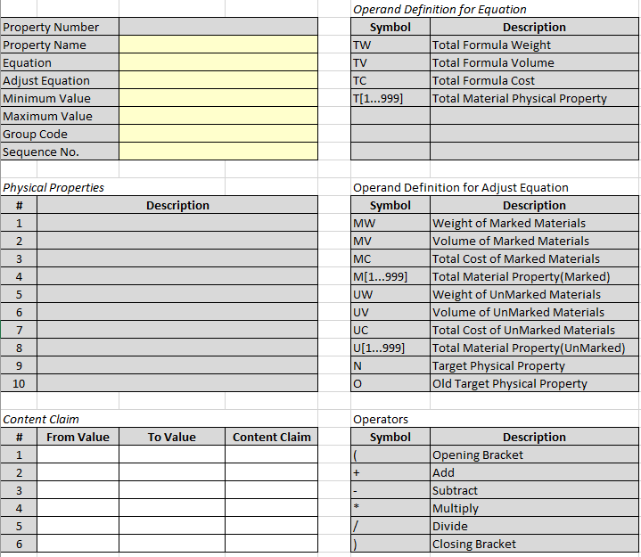

### Field level specification

### Form Elements

|  |  |  |  |  |  |  |  |
| --- | --- | --- | --- | --- | --- | --- | --- |
| Field Caption | Control Type | Mandatory | Editable | Data Type & Length | Default Value | Data Example | Data Entry Source |
| *<Label name>* | *<specify the control type on screen>* | *<specify if field is mandatory>* | *<specify if field is editable>* | *<Specify the data type of the field>* | *<Specify default value>* | *<Provide an example of the data>* | *<Specify the source of the data>* |
| Property Number |  | Yes | Yes | Alpha-numeric | NA | Mike | User entry |
| Property Name |  |  |  |  |  |  |  |
| Equation |  |  |  |  |  |  |  |
| Adjust Equation |  |  |  |  |  |  |  |
| Minimum Value |  |  |  |  |  |  |  |
| Maximum Value |  |  |  |  |  |  |  |
| Group Code |  |  |  |  |  |  |  |
| Sequence No. |  |  |  |  |  |  |  |
| (Physical Properties) # |  |  |  |  |  |  |  |
| Description |  |  |  |  |  |  |  |
| (Content Claim) # |  |  |  |  |  |  |  |
| From Value |  |  |  |  |  |  |  |
| To Value |  |  |  |  |  |  |  |
| Content Claim |  |  |  |  |  |  |  |

### Business Rules and Dependencies

|  |  |  |  |  |
| --- | --- | --- | --- | --- |
| Field Caption | Validation / Business Rules | Error Messages | Data Dependencies | Additional Info/ Notes |
| *<Label name>* | *<Specify the validation\business rules & Calculations applicable to the form element>* | *<List the error message and possible conditions>* | *<Specify the data dependencies>* | *<Provide any additional information here>* |
| Example: User name | User name shall be a valid ERP User Name | For incorrect user name display an error message: “Please provide a valid user name” | None | NA |

### Buttons, Special Functions (Actions) and Drill Downs

|  |  |  |  |  |  |  |
| --- | --- | --- | --- | --- | --- | --- |
| Buttons, Lookups, Drill-Downs | Events (On-Click, Mouse Over etc.) | Validation | Visible, Enabled\Disabled | Lookup Source and Data transfer rule | Navigate To | Error Messages |
| *<Label name>* | *<Specify the operation that would be performed on an event e.g. On-Click, Mouse Over etc.>* | *<Specify the validation rules applicable on button events.>* | *<Specify the default visibility and state>* | *<Specify the source of the lookup and name of the transferred and source fields.>* | *<Specify the target action or screen for the button or drill-down>* | *<List the error message and possible conditions>* |
| Example: ‘Log In’ button | **On-Click: -**If *user Name* and *password* are correct, then allow user to log into the system. | Verify that the user name should be valid. | It should be visible and enabled always. | NA | Application landing page. | “Cannot log into the system as the user is inactive.” |

## Formulation – Header & Toolbar

### Description

The Formulation screen will provide a way to define formulas. This feature will centralize the formulas and provide the means to maintain a library for the formulas that can be used in production. Critical characteristics such as costs, ingredients and by-products will be defined on this screen. This screen will be used to define or edit a specific formula.

The revision number will be a manually entered field to save same formula with different routes. The version number will be an auto-generated number to track the different versions of the formula.

When a formula will be created its status will be “Development”. Next step will be to send it for approval. When it is sent for approval its status will become “Pending” (meaning pending for approval). When it is duly approved its status will become “Approved”. When the “effective from” date is reached for an approved formula its status will become “Active”. When the “Valid Up to” date is passed the status of the formula will become “Obsolete”.

### Use case

Process Manufacturing businesses need a place where they can enter a list of ingredients with their exact proportions or quantities with which different products are manufactured. In the food industry or bakery businesses users will enter their recipes with their exact quantities or percentages in the formula entry screen. In case of paints and chemicals users will enter the exact quantities of the ingredients to make pre-mixes and paints.

### Mock-up

|  |  |  |  |  |  |
| --- | --- | --- | --- | --- | --- |
| **Header** |  |  |  |  |  |
|  |  |  |  |  |  |
| **Formula ID** |  | **Revision** |  | | |
| **Formula Description** |  | **Version** |  | | |
| **Owner** |  | **Effective Date** |  | **Valid Up to** |  |
| **RM Cost Method** |  | **Status** |  | | |

### Field level specification

### Form Elements

|  |  |  |  |  |  |  |  |
| --- | --- | --- | --- | --- | --- | --- | --- |
| Field Caption | Control Type | Mandatory | Editable | Data Type & Length | Default Value | Data Example | Data Entry Source |
| *<Label name>* | *<specify the control type on screen>* | *<specify if field is mandatory>* | *<specify if field is editable>* | *<Specify the data type of the field>* | *<Specify default value>* | *<Provide an example of the data>* | *<Specify the source of the data>* |
| Formula ID | Textbox | Yes | Yes | Alpha-numeric | NA | F-001 | User entry |
| Formula Description | Textbox | Yes | Yes | Alpha-numeric | NA | Liquid Soap | User entry |
| Owner | Lookup | Yes | Yes | Alpha-numeric | Logged-in User | Mike | Users of Acumatica |
| RM Cost Method | Dropdown | Yes | No | Alpha-numeric | Standard | Average | Valuation Methods of Acumatica |
| Revision | Textbox | Yes | Yes | Alpha-numeric | None | A | User Entry |
| Version | Textbox | Yes | No | Alpha-numeric | None | 000001 | Auto-generated |
| Effective Date | Date field | Yes | Yes | Date | Server Date | 12/04/2019 | User Entry |
| Valid Up to | Date field | No | Yes | Date | None | 12/03/2020 | User Entry |
| Status | Textbox | Yes | No | Alpha-numeric | Development | Development | Auto-generated |

### Business Rules and Dependencies

|  |  |  |  |  |
| --- | --- | --- | --- | --- |
| Field Caption | Validation / Business Rules | Error Messages | Data Dependencies | Additional Info/ Notes |
|  |  |  |  |  |
| *<Label name>* | *<Specify the validation\business rules & Calculations applicable to the form element>* | *<List the error message and possible conditions>* | *<Specify the data dependencies>* | *<Provide any additional information here>* |
| Formula ID | * This field will be editable in the insert mode. After saving it will be disabled. * Duplicate Formula ID will not be allowed. * Formula ID cannot be blank. | If a duplicate Formula ID is entered display an error message “This Formula ID already exists”  If Formula ID is blank display an error message “Formula ID cannot be blank.” | None | None |
| Formula Description | None | None | None | None |
| Owner | The owner should be a valid Acumatica user. | If the owner entered is not an Acumatica user error message displayed will be “This is not a valid user. Please select a valid Acumatica user”. | Acumatica users should be defined. | None |
| RM Cost Method | None | None | None | None |
| Revision | Duplicate revision number will not be allowed for the same formula. | If a duplicate revision number is entered error message displayed will be “This revision number already exists” | None | None |
| Version | None | None | None | None |
| Effective Date | The effective date should be a valid date. | If a valid date is not entered the error message displayed will be “Please enter a valid date”. | None | None |
| Valid Up to | The valid up to date should be a valid date and not less than the effective date. | If a valid up to date is not entered the error message displayed will be “Please enter a valid date”.  If the valid up to date is less than effective date then error message displayed will be “Valid Up to date cannot be less than the effective date”. | None | None |
| Status | On creation formula status will be “Development”. When it is sent for approval status will become “Pending”. When it is approved the status will become “Approved”. When the effective date is reached for an “Approved” formula its status will become “Active”. When the valid up to date passes the status will become “Obsolete”. | None | None | None |

### Buttons, Special Functions (Actions) and Drill Downs

|  |  |  |  |  |  |  |
| --- | --- | --- | --- | --- | --- | --- |
| Buttons, Special Functions, Drill-Downs | Events (On-Click, Mouse Over etc.) | Validation | Visible, Enabled\Disabled | Lookup Source and Data transfer rule | Navigate To | Error Messages |
| *<Label name>* | *<Specify the operation that would be performed on an event e.g. On-Click, Mouse Over etc.>* | *<Specify the validation rules applicable on button events.>* | *<Specify the default visibility and state>* | *<Specify the source of the lookup and name of the transferred and source fields.>* | *<Specify the target action or screen for the button or drill-down>* | *<List the error message and possible conditions>* |
| Save & Close | **On-Click: -** Will exit screen after saving data. | Verify that all mandatory fields have been filled.  Verify that all fields have valid data.  Verify that in no field the field data has exceeded field length.  Verify that there is no duplication of formula id. | It should be visible and enabled in the edit mode. | NA | NA | “This formula id already exists”  “Formula ID cannot be blank.”  “This is not a valid user. Please select a valid Acumatica user”. “This revision number already exists” “Please enter a valid date”. “Valid Up to date cannot be less than the effective date”. |
| Save | **On-Click: -** Will save data | Same as above | It should be visible and enabled in the edit mode. | NA | NA | Same as above |
| Cancel | **On-Click: -** Will exit screen without saving | None | It should be visible and enabled always. | NA | NA | NA |
| Add New Record | **On-Click: -** Will re-open screen in insert mode | None | It should be visible and enabled always. | NA | NA | NA |
| Delete | **On-Click: -** Will delete record | Verify that reference does not exist. | It will be disabled in the insert mode. | NA | NA | “Cannot delete record. Reference exists.” |
| Navigate to First Record | **On-Click: -** Will navigate to first record | None | It should be visible and enabled always. | NA | First record of Formulation screen | NA |
| Navigate to Previous Record | **On-Click: -** Will navigate to previous record | None | It should be visible and enabled always. | NA | Previous record of Formulation screen | NA |
| Navigate to Next Record | **On-Click: -** Will navigate to next record | None | It should be visible and enabled always. | NA | Next record of Formulation screen | NA |
| Navigate to Last Record | **On-Click: -** Will navigate to last record | None | It should be visible and enabled always. | NA | Last record of Formulation screen | NA |

## Formulation – Tab 1 (Details)

### Description

On the first tab general information related to the formula such as its classification, policy, approval, status, etc. is maintained.

### Use case

### Mock-up

|  |  |
| --- | --- |
| **Tab 1** |  |
|  |  |
| **Formula Class** |  |
| **Formula Policy** |  |
| **Approval Status** |  |
| **Approved By** |  |
| **Last Updated On** |  |
| **Default RM Warehouse** |  |
| **Reason for Revising** |  |
| **Notes** |  |

### Field level specification

### Form Elements

|  |  |  |  |  |  |  |  |
| --- | --- | --- | --- | --- | --- | --- | --- |
| Field Caption | Control Type | Mandatory | Editable | Data Type & Length | Default Value | Data Example | Data Entry Source |
| *<Label name>* | *<specify the control type on screen>* | *<specify if field is mandatory>* | *<specify if field is editable>* | *<Specify the data type of the field>* | *<Specify default value>* | *<Provide an example of the data>* | *<Specify the source of the data>* |
| Formula Class | Lookup | Yes | Yes | Alpha-numeric | None | FC01 | Formula Class screen |
| Formula Policy | Lookup | Yes | Yes | Alpha-numeric | None | A | Formula Policy screen |
| Approval Status | Textbox | No | No | Alpha-numeric | None | Pending | Auto-generated |
| Approved By | Textbox | No | No | Alpha-numeric | None | Joan | Auto-generated |
| Last Updated On | Date field | No | No | Date | None | 12-23-2019 | Auto-generated |
| Default RM Warehouse | Lookup | No | Yes | Alpha-numeric | None | WH01 | Warehouse screen in Acumatica |
| Reason for Revising | Textbox | No | Yes | Alpha-numeric | None | Frequent and prolonged unavailability of a raw material | User Entry |
| Notes | Textbox | No | Yes | Alpha-numeric | None |  | User Entry |

### Business Rules and Dependencies

|  |  |  |  |  |
| --- | --- | --- | --- | --- |
| Field Caption | Validation / Business Rules | Error Messages | Data Dependencies | Additional Info/ Notes |
| *<Label name>* | *<Specify the validation\business rules & Calculations applicable to the form element>* | *<List the error message and possible conditions>* | *<Specify the data dependencies>* | *<Provide any additional information here>* |
| Formula Class | It should be a valid Formula Class |  | At least one formula class must be defined | NA |
| Formula Policy | It should be a valid Formula Policy |  | At least one formula policy must be defined | NA |
| Approval Status | None |  | None | NA |
| Approved By | None |  | None | NA |
| Last Updated On | None |  | None | NA |
| Default RM Warehouse | It should be a valid Warehouse in Acumatica | If the warehouse entered is not an Acumatica warehouse, error message displayed will be “This is not a valid warehouse. Please select a valid Acumatica warehouse”. | At least one warehouse must be defined | NA |
| Reason for Revising | None |  |  |  |
| Notes | None |  |  |  |

### Buttons, Special Functions (Actions) and Drill Downs

|  |  |  |  |  |  |  |
| --- | --- | --- | --- | --- | --- | --- |
| Buttons, Lookups, Drill-Downs | Events (On-Click, Mouse Over etc.) | Validation | Visible, Enabled\Disabled | Lookup Source and Data transfer rule | Navigate To | Error Messages |
| *<Label name>* | *<Specify the operation that would be performed on an event e.g. On-Click, Mouse Over etc.>* | *<Specify the validation rules applicable on button events.>* | *<Specify the default visibility and state>* | *<Specify the source of the lookup and name of the transferred and source fields.>* | *<Specify the target action or screen for the button or drill-down>* | *<List the error message and possible conditions>* |
|  |  |  |  |  |  |  |
|  |  |  |  |  |  |  |
|  |  |  |  |  |  |  |

## Formulation – Tab 2 (Operations)

### Description

On the second tab details related to operations or routing will be maintained.

### Use case

The same formula may be made using different steps and sets of operations on different production lines. The steps followed for a formula made on one production line may be different from the steps undertaken if the same formula is made on another production line. Therefore, the steps and details of different production lines will be entered on the second tab of the formula and saved by providing different revision numbers.

### Mock-up

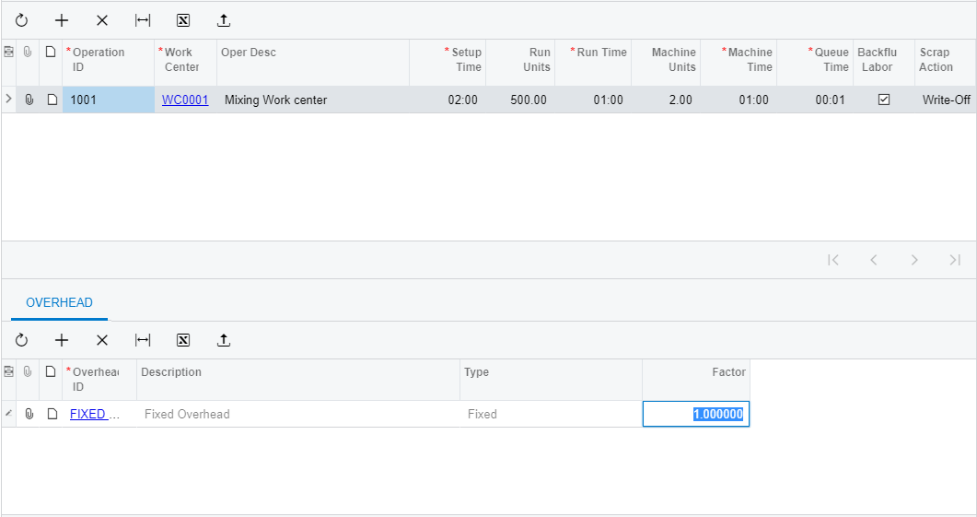

### Field level specification

### Form Elements

|  |  |  |  |  |  |  |  |
| --- | --- | --- | --- | --- | --- | --- | --- |
| Field Caption | Control Type | Mandatory | Editable | Data Type & Length | Default Value | Data Example | Data Entry Source |
| *<Label name>* | *<specify the control type on screen>* | *<specify if field is mandatory>* | *<specify if field is editable>* | *<Specify the data type of the field>* | *<Specify default value>* | *<Provide an example of the data>* | *<Specify the source of the data>* |
| Operation ID | Text field | Yes | No | Alpha-numeric; 10 | None |  | User Entry |
| Work Center | Lookup | Yes | Yes | Alpha-numeric | None |  | Acumatica Work Center |
| Operation Description | Text field | No | Yes | Alpha-numeric; 100 | None |  | User Entry |
| Setup Time | Time | No | Yes | HH:MM | 00:00 |  | User Entry |
| Run Units | Text field | No | Yes | Numeric | 0 |  | User Entry |
| Run Time | Time | No | Yes | HH:MM | 00:00 |  | User Entry |
| Machine Units | Text field | No | Yes | Numeric | 0 |  | User Entry |
| Machine Time | Time | No | Yes | HH:MM | 00:00 |  | User Entry |
| Queue Time | Time | No | Yes | HH:MM | 00:00 |  | User Entry |
| Back Flush Labor | Checkbox | Yes | Yes | Check / Uncheck | Uncheck |  | Check/Uncheck |
| Scrap Action | Dropdown | Yes | Yes | Select from Drop-down | None |  | Write-off/Quarantine/No Action |
| Overhead ID | Look-up | No | Yes | Alpha-numeric | None |  | Acumatica Overhead ID |
| Description | Text field | No | Yes | Alpha-numeric | None |  | Acumatica Overhead Description |
| Type | Text field | No | No | Alpha-numeric | None |  | Acumatica Overhead Type |
| Factor | Numeric | No | Yes | Numeric | None |  | User Entry |

### Business Rules and Dependencies

|  |  |  |  |  |
| --- | --- | --- | --- | --- |
| Field Caption | Validation / Business Rules | Error Messages | Data Dependencies | Additional Info/ Notes |
| *<Label name>* | *<Specify the validation\business rules & Calculations applicable to the form element>* | *<List the error message and possible conditions>* | *<Specify the data dependencies>* | *<Provide any additional information here>* |
| Operation ID | None | None | None | NA |
| Work Center | Should be a valid Acumatica Work Center. | If the work center entered is not an Acumatica work center, error message displayed will be “This is not a valid work center. Please select a valid Acumatica work center”. | Work Center must be defined in Acumatica. | NA |
| Operation Description | None | None | None | NA |
| Setup Time | None | None | None | NA |
| Run Units | None | None | None | NA |
| Run Time | None | None | None | NA |
| Machine Units | None | None | None | NA |
| Machine Time | None | None | None | NA |
| Queue Time | None | None | None | NA |
| Back Flush Labor | None | None | None | NA |
| Scrap Action | None | None | None | NA |
| Overhead ID | Should be a valid Acumatica Overhead ID. | If the Overhead ID entered is not an Acumatica Overhead ID, error message displayed will be “This is not a valid Overhead ID. Please select a valid Acumatica Overhead ID”. | Overhead ID must be defined in Acumatica. | NA |
| Description | Automatically fetch description from Acumatica Overhead ID | None | Overhead ID must be defined in Acumatica. | NA |
| Type | Automatically fetch type from Acumatica Overhead ID | None | Overhead ID must be defined in Acumatica. | NA |
| Factor | None | None | None | NA |

### Buttons, Special Functions (Actions) and Drill Downs

|  |  |  |  |  |  |  |
| --- | --- | --- | --- | --- | --- | --- |
| Buttons, Lookups, Drill-Downs | Events (On-Click, Mouse Over etc.) | Validation | Visible, Enabled\Disabled | Lookup Source and Data transfer rule | Navigate To | Error Messages |
| *<Label name>* | *<Specify the operation that would be performed on an event e.g. On-Click, Mouse Over etc.>* | *<Specify the validation rules applicable on button events.>* | *<Specify the default visibility and state>* | *<Specify the source of the lookup and name of the transferred and source fields.>* | *<Specify the target action or screen for the button or drill-down>* | *<List the error message and possible conditions>* |
| Example: ‘Log In’ button | **On-Click: -**If *user Name* and *password* are correct, then allow user to log into the system. | Verify that the user name should be valid. | It should be visible and enabled always. | NA | Application landing page. | “Cannot log into the system as the user is inactive.” |
|  |  |  |  |  |  |  |
|  |  |  |  |  |  |  |

## Formulation – Tab 3 (Consumables)

### Description

### Use case

### Mock-up

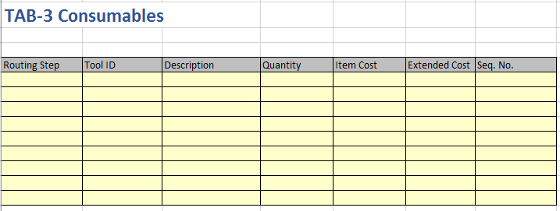

### Field level specification

### Form Elements

|  |  |  |  |  |  |  |  |
| --- | --- | --- | --- | --- | --- | --- | --- |
| Field Caption | Control Type | Mandatory | Editable | Data Type & Length | Default Value | Data Example | Data Entry Source |
| *<Label name>* | *<specify the control type on screen>* | *<specify if field is mandatory>* | *<specify if field is editable>* | *<Specify the data type of the field>* | *<Specify default value>* | *<Provide an example of the data>* | *<Specify the source of the data>* |
| Operation ID | Lookup | Yes | No | Alphanumeric; 10 | None | 1010 | Operations from Tab 2 |
| Tool ID | Lookup | Yes | No |  | None |  | Acumatica Tool Master |
| Description | Text Box | No |  |  | None |  | Auto-filled |
| Quantity | Text Box | Yes |  |  | None |  | User Entry |
| Item Cost | Text Box | Yes |  |  | None |  | Auto-filled |
| Extended Cost | Calculated Field | Yes |  |  | None |  | Auto calculated  Quantity X Item Cost |
| Sequence no. | Text Box | Yes |  |  | None |  | User Entry |

### Business Rules and Dependencies

|  |  |  |  |  |
| --- | --- | --- | --- | --- |
| Field Caption | Validation / Business Rules | Error Messages | Data Dependencies | Additional Info/ Notes |
| *<Label name>* | *<Specify the validation\business rules & Calculations applicable to the form element>* | *<List the error message and possible conditions>* | *<Specify the data dependencies>* | *<Provide any additional information here>* |
| Operation ID | Operation ID should be a valid Operation ID defined on Tab 2 of this screen | For incorrect Operation ID display an error message: “Please provide a valid Operation ID” | Operation ID must be defined on Tab 2 of this screen | NA |
| Tool ID | Tool ID should be a valid Tool ID defined in Acumatica | For incorrect Tool ID display an error message: “Please provide a valid Tool ID” | Tool ID must be defined in Acumatica | NA |
| Description |  |  | Tool ID must be defined in Acumatica | NA |
| Quantity |  |  |  |  |
| Item Cost |  |  |  |  |
| Extended Cost |  |  |  |  |
| Sequence No. |  |  |  |  |

### Buttons, Special Functions (Actions) and Drill Downs

|  |  |  |  |  |  |  |
| --- | --- | --- | --- | --- | --- | --- |
| Buttons, Lookups, Drill-Downs | Events (On-Click, Mouse Over etc.) | Validation | Visible, Enabled\Disabled | Lookup Source and Data transfer rule | Navigate To | Error Messages |
| *<Label name>* | *<Specify the operation that would be performed on an event e.g. On-Click, Mouse Over etc.>* | *<Specify the validation rules applicable on button events.>* | *<Specify the default visibility and state>* | *<Specify the source of the lookup and name of the transferred and source fields.>* | *<Specify the target action or screen for the button or drill-down>* | *<List the error message and possible conditions>* |
|  |  |  |  |  |  |  |
|  |  |  |  |  |  |  |
|  |  |  |  |  |  |  |

## Formulation – Tab 4 (Items)

### Description

This tab will used to enter the details of items that will be used in the formula. The physical properties of the items will be displayed and there will be the ability to modify the formula based on the desired values of physical material properties.

### Use case

### Mock-up

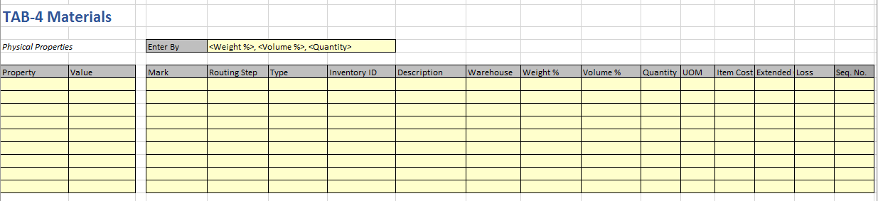

### Field level specification

### Form Elements

|  |  |  |  |  |  |  |  |
| --- | --- | --- | --- | --- | --- | --- | --- |
| Field Caption | Control Type | Mandatory | Editable | Data Type & Length | Default Value | Data Example | Data Entry Source |
| *<Label name>* | *<specify the control type on screen>* | *<specify if field is mandatory>* | *<specify if field is editable>* | *<Specify the data type of the field>* | *<Specify default value>* | *<Provide an example of the data>* | *<Specify the source of the data>* |
| Property | Lookup |  |  |  |  |  |  |
| Value | Textbox |  |  | Alpha-numeric |  |  |  |
| Enter By | Drop Down |  |  |  |  |  | Weight%, Volume %, Quantity |
| Mark | Checkbox |  |  |  | Checked |  |  |
| Operation ID | Text Field | Yes | Yes | Alpha-numeric | None | 1010 | User Entry |
| Type |  | Yes |  |  |  |  |  |
| Inventory ID | Lookup | Yes | Yes | Alpha-numeric | None | RM-001 | Acumatica Item Master |
| Description | Textbox | Yes | No | Alpha-numeric | None | Chlorine | Acumatica Item Master |
| Warehouse | Lookup | Yes | Yes | Alpha-numeric | None | L01 | Acumatica Warehouse |
| Weight % |  |  |  | Numeric |  |  |  |
| Volume % |  |  |  | Numeric |  |  |  |
| Quantity | Textbox | Yes | Yes | Numeric | None | 5 | User Entry |
| UOM | Lookup | Yes | Yes | Alpha-numeric | None | GM | Acumatica Unit of Measure |
| Item Cost | Textbox |  |  | Numeric |  |  |  |
| Extended Cost | Textbox |  |  | Numeric |  |  |  |
| Loss | Textbox |  |  | Numeric |  |  |  |
| Seq. No. |  |  |  |  |  |  |  |

### Business Rules and Dependencies

|  |  |  |  |  |
| --- | --- | --- | --- | --- |
| Field Caption | Validation / Business Rules | Error Messages | Data Dependencies | Additional Info/ Notes |
| *<Label name>* | *<Specify the validation\business rules & Calculations applicable to the form element>* | *<List the error message and possible conditions>* | *<Specify the data dependencies>* | *<Provide any additional information here>* |
|  |  |  |  |  |

### Buttons, Special Functions (Actions) and Drill Downs

|  |  |  |  |  |  |  |
| --- | --- | --- | --- | --- | --- | --- |
| Buttons, Lookups, Drill-Downs | Events (On-Click, Mouse Over etc.) | Validation | Visible, Enabled\Disabled | Lookup Source and Data transfer rule | Navigate To | Error Messages |
| *<Label name>* | *<Specify the operation that would be performed on an event e.g. On-Click, Mouse Over etc.>* | *<Specify the validation rules applicable on button events.>* | *<Specify the default visibility and state>* | *<Specify the source of the lookup and name of the transferred and source fields.>* | *<Specify the target action or screen for the button or drill-down>* | *<List the error message and possible conditions>* |
|  |  |  |  |  |  |  |
|  |  |  |  |  |  |  |
|  |  |  |  |  |  |  |

## Formulation – Tab 5 (By-Product)

### Description

This tab will be used to enter the details of by-products that will be created from the use of the formula.

### Use case

An example of by-product can be molasses generated in sugar refining process batch.

### Mock-up

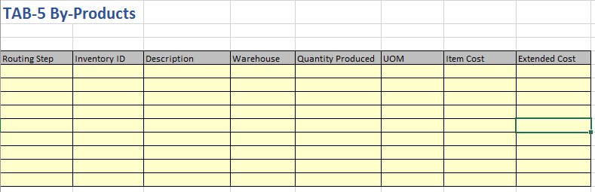

### Field level specification

### Form Elements

|  |  |  |  |  |  |  |  |
| --- | --- | --- | --- | --- | --- | --- | --- |
| Field Caption | Control Type | Mandatory | Editable | Data Type & Length | Default Value | Data Example | Data Entry Source |
| *<Label name>* | *<specify the control type on screen>* | *<specify if field is mandatory>* | *<specify if field is editable>* | *<Specify the data type of the field>* | *<Specify default value>* | *<Provide an example of the data>* | *<Specify the source of the data>* |
| Operation ID | Lookup | Yes | Yes | Alpha-numeric | None | 1010 | Operations from Tab 2 |
| Inventory ID | Lookup | Yes | Yes | Alpha-numeric | None | RM-001 | Acumatica Item Master |
| Description | Textbox | Yes | No | Alpha-numeric | None | Chlorine | Acumatica Item Master |
| Warehouse | Lookup | Yes | Yes | Alpha-numeric | None | L01 | Acumatica Warehouse |
| Quantity Produced | Textbox | Yes | Yes | Numeric | None | 5 | User Entry |
| UOM | Lookup | Yes | Yes | Alpha-numeric | None | GM | Acumatica Unit of Measure |
| Item Cost | Textbox | Yes | No | Numeric | None | 1.5 | Acumatica Item Master |
| Extended Cost | Textbox | Yes | No | Numeric | None | 7.5 | Auto calculated; Quantity Produced X Item Cost |

### Business Rules and Dependencies

|  |  |  |  |  |
| --- | --- | --- | --- | --- |
| Field Caption | Validation / Business Rules | Error Messages | Data Dependencies | Additional Info/ Notes |
| *<Label name>* | *<Specify the validation\business rules & Calculations applicable to the form element>* | *<List the error message and possible conditions>* | *<Specify the data dependencies>* | *<Provide any additional information here>* |
| Operation ID | Operation ID should be a valid Operation ID defined on Tab 2 of this screen | For incorrect Operation ID display an error message: “Please provide a valid Operation ID” | Operation ID must be defined on Tab 2 of this screen | None |
| Inventory ID | Inventory ID should be a valid Inventory ID defined in Acumatica | For incorrect Inventory ID display an error message: “Please provide a valid Inventory ID” | Inventory ID must be defined in Acumatica | None |
| Description | None | None | None | None |
| Warehouse | Warehouse should be a valid warehouse defined in Acumatica | For incorrect Warehouse display an error message: “Please provide a valid Warehouse” | Warehouse must be defined in Acumatica | None |
| Quantity Produced | None | None | None | None |
| UOM | UOM should be a valid UOM defined in Acumatica | For incorrect UOM display an error message: “Please provide a valid UOM” | UOM must be defined in Acumatica | None |
| Item Cost | None | None | None | None |
| Extended Cost | None | None | None | None |

### Buttons, Special Functions (Actions) and Drill Downs

|  |  |  |  |  |  |  |
| --- | --- | --- | --- | --- | --- | --- |
| Buttons, Lookups, Drill-Downs | Events (On-Click, Mouse Over etc.) | Validation | Visible, Enabled\Disabled | Lookup Source and Data transfer rule | Navigate To | Error Messages |
| *<Label name>* | *<Specify the operation that would be performed on an event e.g. On-Click, Mouse Over etc.>* | *<Specify the validation rules applicable on button events.>* | *<Specify the default visibility and state>* | *<Specify the source of the lookup and name of the transferred and source fields.>* | *<Specify the target action or screen for the button or drill-down>* | *<List the error message and possible conditions>* |
|  |  |  |  |  |  |  |
|  |  |  |  |  |  |  |
|  |  |  |  |  |  |  |

## Formulation – Tab 6 (QC)

### Description

### Use case

### Mock-up

### Field level specification

### Form Elements

|  |  |  |  |  |  |  |  |
| --- | --- | --- | --- | --- | --- | --- | --- |
| Field Caption | Control Type | Mandatory | Editable | Data Type & Length | Default Value | Data Example | Data Entry Source |
| *<Label name>* | *<specify the control type on screen>* | *<specify if field is mandatory>* | *<specify if field is editable>* | *<Specify the data type of the field>* | *<Specify default value>* | *<Provide an example of the data>* | *<Specify the source of the data>* |
| Formula Class |  |  |  |  |  |  |  |
| Formula Policy |  |  |  |  |  |  |  |
| Approval Status |  |  |  |  |  |  |  |
| Approved By |  |  |  |  |  |  |  |
| Last Updated On |  |  |  |  |  |  |  |
| Default RM Warehouse |  |  |  |  |  |  |  |
| Reason for Revising |  |  |  |  |  |  |  |
| Notes |  |  |  |  |  |  |  |
|  |  |  |  |  |  |  |  |

### Business Rules and Dependencies

|  |  |  |  |  |
| --- | --- | --- | --- | --- |
| Field Caption | Validation / Business Rules | Error Messages | Data Dependencies | Additional Info/ Notes |
| *<Label name>* | *<Specify the validation\business rules & Calculations applicable to the form element>* | *<List the error message and possible conditions>* | *<Specify the data dependencies>* | *<Provide any additional information here>* |
| Formula Class |  |  |  |  |
| Formula Policy |  |  |  |  |
| Approval Status |  |  |  |  |
| Approved By |  |  |  |  |
| Last Updated On |  |  |  |  |
| Default RM Warehouse |  |  |  |  |
| Reason for Revising |  |  |  |  |
| Notes |  |  |  |  |

### Buttons, Special Functions (Actions) and Drill Downs

|  |  |  |  |  |  |  |
| --- | --- | --- | --- | --- | --- | --- |
| Buttons, Lookups, Drill-Downs | Events (On-Click, Mouse Over etc.) | Validation | Visible, Enabled\Disabled | Lookup Source and Data transfer rule | Navigate To | Error Messages |
| *<Label name>* | *<Specify the operation that would be performed on an event e.g. On-Click, Mouse Over etc.>* | *<Specify the validation rules applicable on button events.>* | *<Specify the default visibility and state>* | *<Specify the source of the lookup and name of the transferred and source fields.>* | *<Specify the target action or screen for the button or drill-down>* | *<List the error message and possible conditions>* |
|  |  |  |  |  |  |  |
|  |  |  |  |  |  |  |
|  |  |  |  |  |  |  |

## Formulation – Tab 7 (Costing)

### Description

This tab will be used to do the product cost analysis using different valuation methods.

### Use case

### Mock-up

### Field level specification

### Form Elements

|  |  |  |  |  |  |  |  |
| --- | --- | --- | --- | --- | --- | --- | --- |
| Field Caption | Control Type | Mandatory | Editable | Data Type & Length | Default Value | Data Example | Data Entry Source |
| *<Label name>* | *<specify the control type on screen>* | *<specify if field is mandatory>* | *<specify if field is editable>* | *<Specify the data type of the field>* | *<Specify default value>* | *<Provide an example of the data>* | *<Specify the source of the data>* |
| Formula Class |  |  |  |  |  |  |  |
| Formula Policy |  |  |  |  |  |  |  |
| Approval Status |  |  |  |  |  |  |  |
| Approved By |  |  |  |  |  |  |  |
| Last Updated On |  |  |  |  |  |  |  |
| Default RM Warehouse |  |  |  |  |  |  |  |
| Reason for Revising |  |  |  |  |  |  |  |
| Notes |  |  |  |  |  |  |  |
|  |  |  |  |  |  |  |  |

### Business Rules and Dependencies

|  |  |  |  |  |
| --- | --- | --- | --- | --- |
| Field Caption | Validation / Business Rules | Error Messages | Data Dependencies | Additional Info/ Notes |
| *<Label name>* | *<Specify the validation\business rules & Calculations applicable to the form element>* | *<List the error message and possible conditions>* | *<Specify the data dependencies>* | *<Provide any additional information here>* |
| Example: User name | User name shall be a valid ERP User Name | For incorrect user name display an error message: “Please provide a valid user name” | None | NA |

### Buttons, Special Functions (Actions) and Drill Downs

|  |  |  |  |  |  |  |
| --- | --- | --- | --- | --- | --- | --- |
| Buttons, Lookups, Drill-Downs | Events (On-Click, Mouse Over etc.) | Validation | Visible, Enabled\Disabled | Lookup Source and Data transfer rule | Navigate To | Error Messages |
| *<Label name>* | *<Specify the operation that would be performed on an event e.g. On-Click, Mouse Over etc.>* | *<Specify the validation rules applicable on button events.>* | *<Specify the default visibility and state>* | *<Specify the source of the lookup and name of the transferred and source fields.>* | *<Specify the target action or screen for the button or drill-down>* | *<List the error message and possible conditions>* |
| Example: ‘Log In’ button | **On-Click: -**If *user Name* and *password* are correct, then allow user to log into the system. | Verify that the user name should be valid. | It should be visible and enabled always. | NA | Application landing page. | “Cannot log into the system as the user is inactive.” |
|  |  |  |  |  |  |  |
|  |  |  |  |  |  |  |

## Bill of Material - Header

### Description

This screen will be used to create Bill of Material to define the packaging ingredients for bulk items and finished good items and also fill size for finished goods items.

### Use case

### Mock-up

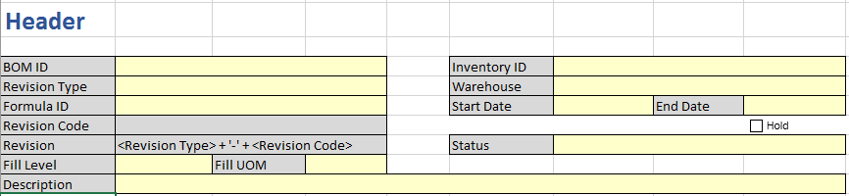

### Field level specification

### Form Elements

|  |  |  |  |  |  |  |  |
| --- | --- | --- | --- | --- | --- | --- | --- |
| Field Caption | Control Type | Mandatory | Editable | Data Type & Length | Default Value | Data Example | Data Entry Source |
| *<Label name>* | *<specify the control type on screen>* | *<specify if field is mandatory>* | *<specify if field is editable>* | *<Specify the data type of the field>* | *<Specify default value>* | *<Provide an example of the data>* | *<Specify the source of the data>* |
| BOM ID | As per standard Acumatica BOM | Yes | As per standard Acumatica BOM | As per standard Acumatica BOM | None |  | Auto-generated or Manual entry |
| Revision Type | Dropdown | Yes | No | Alphanumeric; 12 |  |  | Drop-down options:  Mix  Fill  Assembly  Intermediate |
| Formula ID | Lookup | Yes | No | Same as Formula ID on Formulation screen | None |  | Formulation |
| Revision Code | Text | Yes | No | Same as Formula revision no. on Formulation screen |  |  | Auto-filled |
| Revision | Text | Yes | No | Alphanumeric; |  |  | Revision Type – Revision Code |
| Fill Level | Numeric | Yes when Revision type is Mix or Fill | Yes |  | 0 | 100 | User Entry |
| Fill UOM | Lookup | Yes when Revision type is Mix or Fill | Yes | As per Acumatica Unit of Measure | None | GM | Acumatica UOM |
| Description | Text | Yes | Yes | Alphanumeric |  |  | User Entry |
| Inventory ID | Lookup | Yes | Yes | Alphanumeric |  |  | Acumatica Inventory Master |
| Warehouse | Lookup | Yes | Yes | Alphanumeric |  |  | Acumatica Warehouse |
| Start Date | Date field | Yes | Yes | Date field |  |  | User Entry |
| End Date | Date field | Yes | Yes | Date field |  |  | User Entry |
| Status | Text | Yes | No | Alphanumeric |  |  | Auto-generated |

### Business Rules and Dependencies

|  |  |  |  |  |
| --- | --- | --- | --- | --- |
| Field Caption | Validation / Business Rules | Error Messages | Data Dependencies | Additional Info/ Notes |
| *<Label name>* | *<Specify the validation\business rules & Calculations applicable to the form element>* | *<List the error message and possible conditions>* | *<Specify the data dependencies>* | *<Provide any additional information here>* |
| BOM ID | * This field will be editable in the insert mode. After saving it will be disabled. * Duplicate BOM ID will not be allowed. * BOM ID cannot be blank. |  | None | None |
| Revision Type | Drop-down options:  Mix  Fill  Assembly  Intermediate | None | None | None |
| Formula ID | * Field will be disabled if revision type selected is Assembly * Should be a valid Formula ID | If the Formula ID entered is not defined on Formulation screen, error message displayed will be “This is not a valid Formula ID. Please select a valid Formula ID”. | Formula ID must be defined in Formulation. | None |
| Revision Code | * Selected Formula Revision will be copied to this field * In case of Assembly BOM user will manually enter revision code |  |  |  |
| Revision | * Will be Revision Type – Revision Code |  |  |  |
| Fill Level | * Field will be blank and greyed out if revision type is assembly or intermediate |  |  |  |
| Fill UOM | * Field will be blank and greyed out if revision type is assembly or intermediate * Should be a valid UOM in Acumatica | If the UOM entered is not defined in Acumatica, error message displayed will be “This is not a valid UOM. Please select a valid UOM”. |  |  |
| Description |  |  |  |  |
| Inventory ID | * Should be a valid Acumatica Inventory ID | If the Inventory ID entered is not defined in Acumatica, error message displayed will be “This is not a valid Inventory ID. Please select a valid Inventory ID”. |  |  |
| Warehouse | * Should be a valid Acumatica Warehouse ID | If the Warehouse ID entered is not defined in Acumatica, error message displayed will be “This is not a valid Warehouse ID. Please select a valid Warehouse ID”. |  |  |
| Start Date | * The start date cannot be greater than the end date | “The start date cannot be greater than the end date” |  |  |
| End Date | * The end date cannot be lesser than start date | “The end date cannot be lesser than the start date.” |  |  |
| Status |  |  |  |  |

### Buttons, Special Functions (Actions) and Drill Downs

|  |  |  |  |  |  |  |
| --- | --- | --- | --- | --- | --- | --- |
| Buttons, Lookups, Drill-Downs | Events (On-Click, Mouse Over etc.) | Validation | Visible, Enabled\Disabled | Lookup Source and Data transfer rule | Navigate To | Error Messages |
| *<Label name>* | *<Specify the operation that would be performed on an event e.g. On-Click, Mouse Over etc.>* | *<Specify the validation rules applicable on button events.>* | *<Specify the default visibility and state>* | *<Specify the source of the lookup and name of the transferred and source fields.>* | *<Specify the target action or screen for the button or drill-down>* | *<List the error message and possible conditions>* |
| Example: ‘Log In’ button | **On-Click: -**If *user Name* and *password* are correct, then allow user to log into the system. | Verify that the user name should be valid. | It should be visible and enabled always. | NA | Application landing page. | “Cannot log into the system as the user is inactive.” |

## Bill of Material – Middle section

### Description

This section will be used to enter the routing details for Bill of Material.

### Use case

### Mock-up

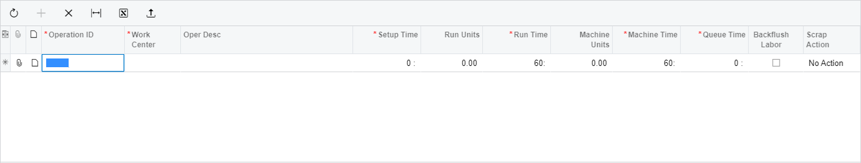

### Field level specification

As per standard Acumatica Bill of Material.

## Bill of Material – Tab 1

### Description

This tab will be used to enter the details of materials used in packaging.

### Use case

### Mock-up

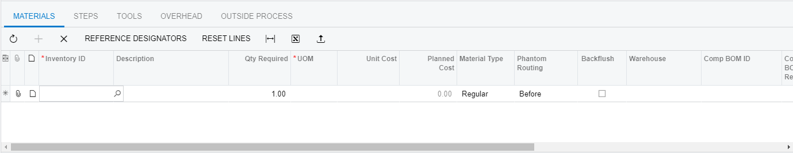

### Field level specification

As per standard Acumatica Bill of Material.

## Bill of Material – Tab 2

### Description

This tab will be used to enter the details of routing in packaging.

### Use case

### Mock-up

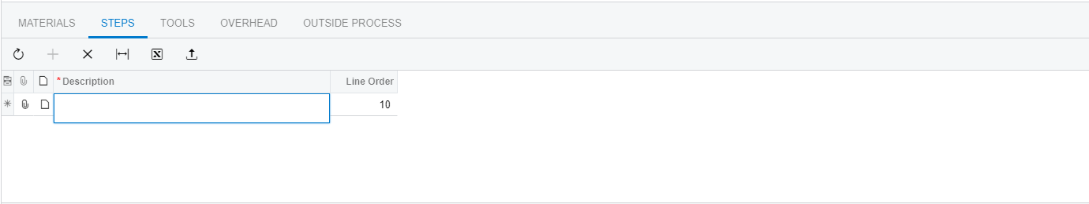

### Field level specification

As per standard Acumatica Bill of Material.

## Bill of Material – Tab 3

### Description

This tab will be used to enter the details of overheads in packaging.

### Use case

### Mock-up

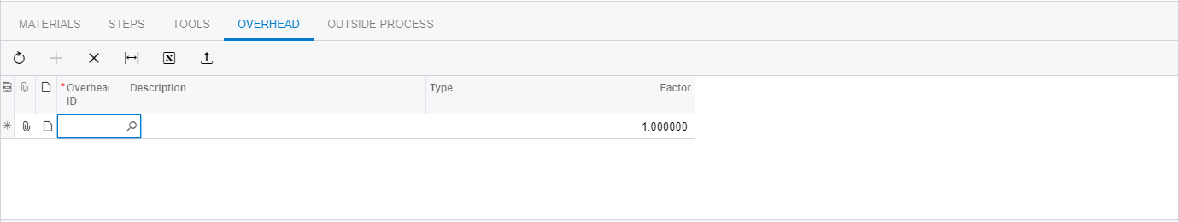

### Field level specification

As per standard Acumatica Bill of Material.

## Bill of Material – Tab 4

### Description

This tab will be used to enter the details of outside process in packaging.

### Use case

### Mock-up

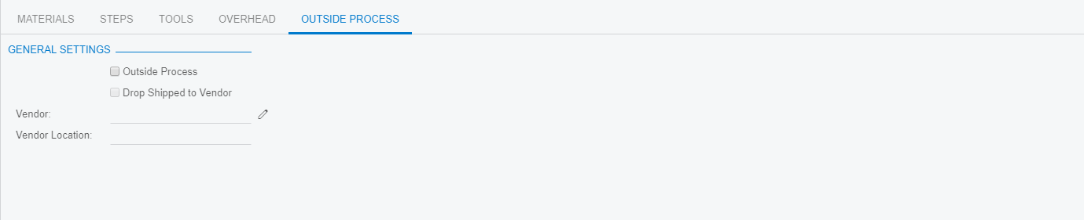

### Field level specification

As per standard Acumatica Bill of Material.